Resolution proof: thou should^{st} know^{st}:

If p ∨ r and ¬p ∨ q are both true then __________ is also true
If p and ¬p ∨ q are both true then __________ is also true
If ¬p and p ∨ r are both true then __________ is also true
Rewrite ¬(ab) as a clause
Rewrite (a ∨ bc) as a clause

m ∨ ¬n  ¬m ∨ q  n_____  ∴q | ¬p ∨ t  ¬q ∨ s  ¬r ∨ st  p ∨ q ∨ r ∨ u  ∴ s ∨ t ∨ u

Consider Ackerman’s Function shown below
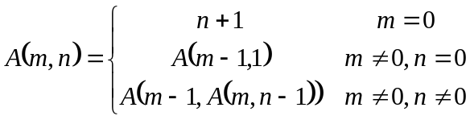 | Prove the following property of Ackerman’s Function by induction.  *Assume m > 0 & n > 0

First prove: 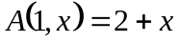 | Then prove: 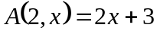  Hint: Yes, you may (should) use the results of previous property/proof

Prove 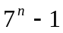 is divisible by 6. | Prove 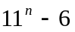 is divisible by 5.

Given 3-cent and 7-cent stamps, for what value of n can you prove that amount of postage that is at least n-cents can be made from 3-cent and 7-cent stamps? Prove it.

Prove by Induction
1² + 2² + ... + n² = (n)(n+1)(2n+1)/6 | If 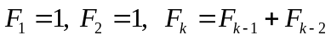,  then 